SIMATS ENGINEERING - TOC ASSESSMENT SOLUTIONS

COURSE OUTCOME COVERED

CO1: Analyze fundamental mathematical concepts of automata theory for formal languages and decision problems.(BL:3)

Assessment Tool Weightage: 40%

QUESTIONS: 5 Total Marks:25
Duration : 1 Hour
Simulation

Code of Conduct:

I Sanjay Manesh M (192511362) (Name / Reg No) certify that this submission is my original work and that I have adhered to the guidelines specified for this assessment.
I understand that any violation of academic integrity rules will result in disciplinary action.

Signature of the student:
Sanjay Manesh M

THEORY OF COMPUTATION (CSA1304)

CO1 Assessment Tool 2 - Simulation

Question 1 — NFA model for an automatic door system

Solution. Inputs: P = person detected; N = no person detected. States describe the door position. Nondeterminism models sensor delay or the choice to keep the door open briefly.
Formal model: M = (Q, Σ, δ, q0, F), where Q = {Closed, Opening, Open, Closing}, Σ = {P,N}, q0 = Closed, and F = {Closed}. A run is accepted when it ends in the fully Closed state.

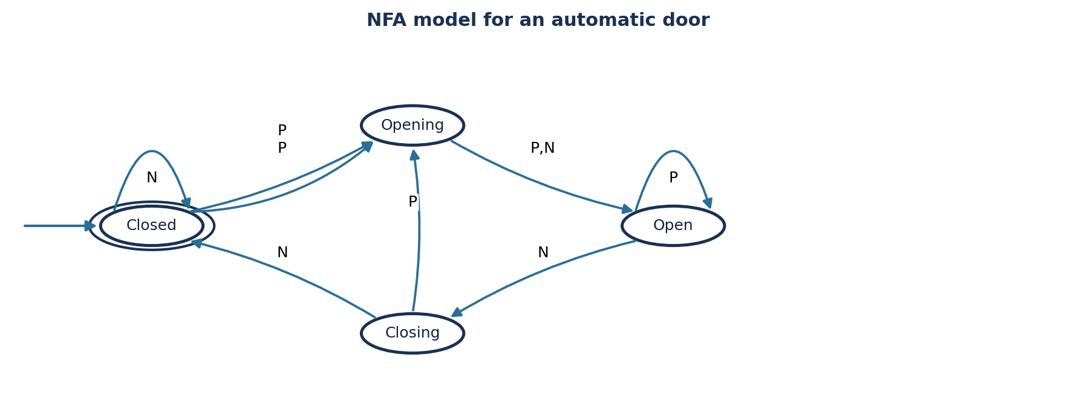
Current state | Input P | Input N
→ * Closed | {Closed, Opening} | {Closed}
Opening | {Open} | {Open}
Open | {Open} | {Open, Closing}
Closing | {Opening} | {Closed}

For input P P N N, one valid path is Closed —P→ Opening —P→ Open —N→ Closing —N→ Closed. The input is accepted because this path ends in Closed.

Design note: The transition Open on N has two possible next states: Open (wait) or Closing (start closing). This is the key nondeterministic choice. In a real controller, safety interlocks and sensor validation would need to be implemented beyond this abstract automaton.

Question 2 — Finite automaton for a traffic light controller

Solution: Use a Moore-style finite-state machine: the state determines which lamp is active, and input T means that the current timer has expired. The normal sequence is Red → Green → Yellow → Red.
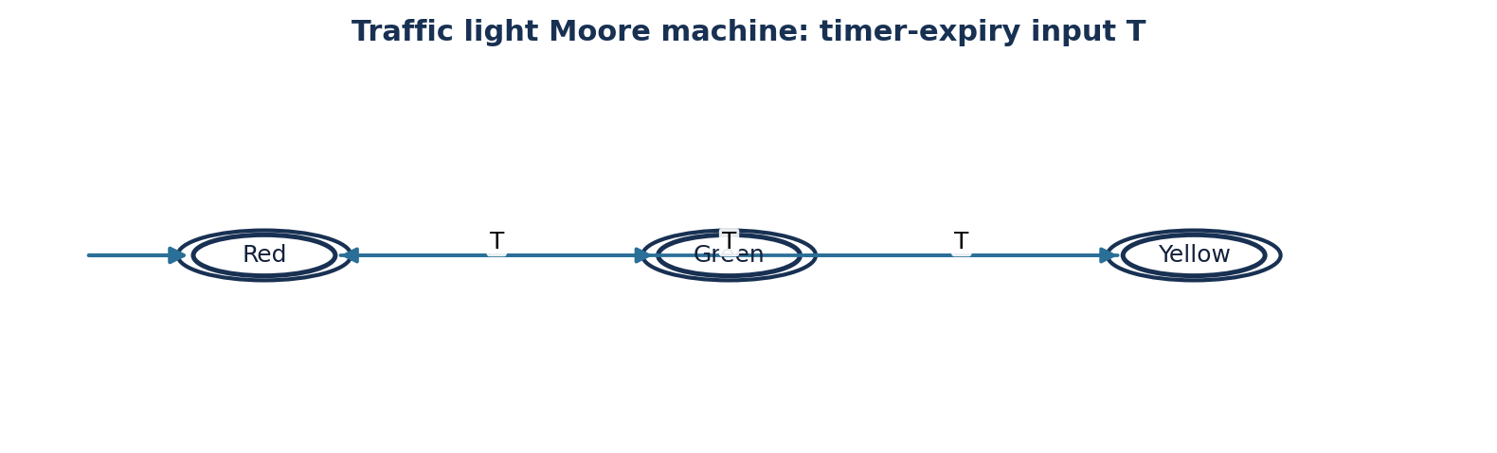
Figure 2. Cyclic traffic-light state machine
Formal model: Q = {Red, Green, Yellow}, Σ = {T}, q0 = Red, and F = Q because each light state is a valid operational state.

State | Output | Nominal duration | Transition on T
→ Red | Red lamp ON | 30 seconds | Green
Green | Green lamp ON | 25 seconds | Yellow
Yellow | Yellow lamp ON | 5 seconds | Red

Timing and safety explanation

- A hardware timer is loaded with the duration associated with the current state. When it expires, it produces input T and triggers the next state.
- The transition function has no dead end: Yellow on T returns to Red, so the sequence can continue indefinitely.
- The machine never jumps directly from Green to Red; Yellow is always included in the normal cycle.
- For pedestrian support, add a pedestrian-request input and a Red+Walk state. Honour the request only at a safe phase boundary.
- For emergency vehicles, add an emergency input and an All-Red clearance state. Route the controller through All-Red before resuming normal operation.

Question 3 — DFA that accepts strings ending in “ab”

Solution. Alphabet Σ = {a,b}. The target language is L = {w ∈ Σ* : w ends with ab}. The DFA remembers the longest suffix that is also a prefix of the pattern “ab”.

State | Meaning | a | b | Status
→ q0 | No useful suffix | q1 | q0 | Non-final
q1 | Current suffix is a | q1 | q2 | Non-final
* q2 | Current suffix is ab | q1 | q0 | Final

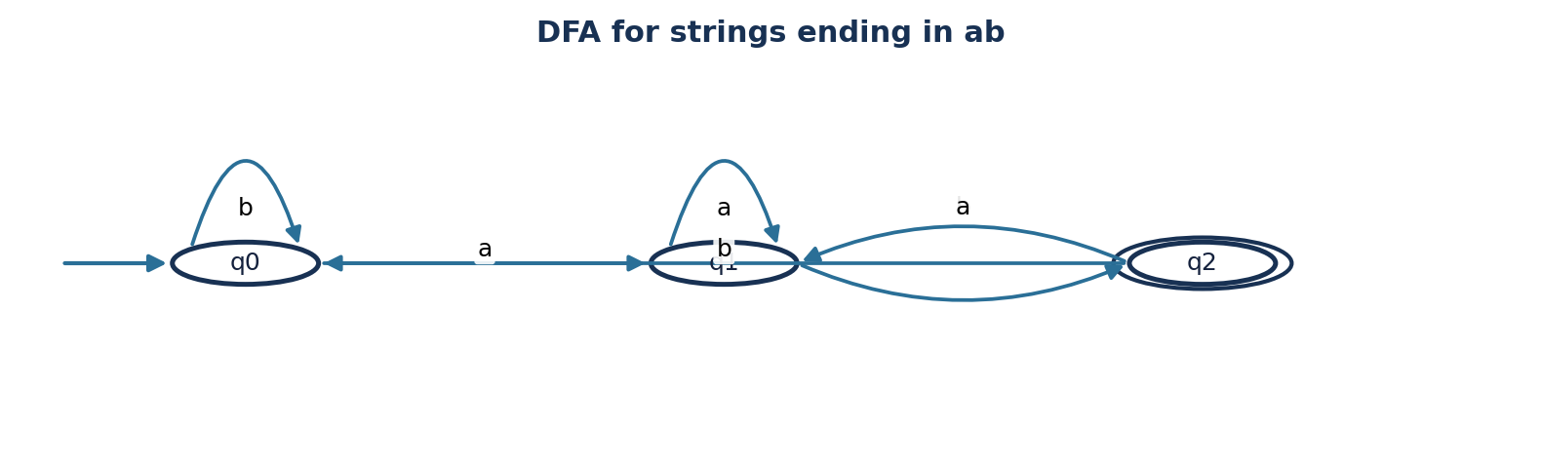
Figure 3. DFA for suffix ab

Simulation for W = aaabab
Step | Read symbol | State before | State after
0 | — | — | q0
1 | a | q0 | q1
2 | a | q1 | q1
3 | a | q1 | q1
4 | b | q1 | q2
5 | a | q2 | q1
6 | b | q1 | q2

The final state is q2, so aaabab is ACCEPTED. Its last two symbols are “ab”. A string such as aabba ends with “ba”, so it is rejected.

Question 4 — DFA accepting only c, bc, and bcaaa

Solution. Alphabet Σ = {a,b,c}. The accepted language is exactly L = {c, bc, bcaaa}; no other string is accepted. A dead state D catches every invalid continuation and loops on all symbols.
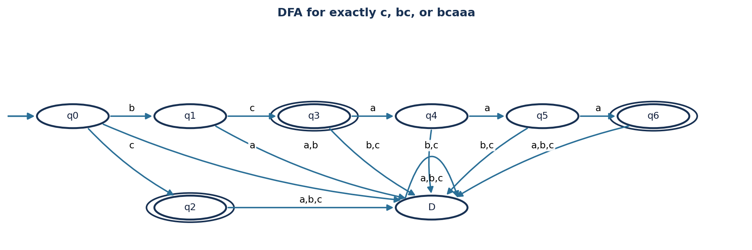
Figure 4. DFA for the three exact strings
State | Prefix represented | a | b | c | Final?
→ q0 | Empty prefix | D | q1 | q2 | No
q1 | b | D | D | q3 | No
* q2 | c | D | D | D | Yes
* q3 | bc | q4 | D | D | Yes
q4 | bca | q5 | D | D | No
q5 | bcaa | q6 | D | D | No
* q6 | bcaaa | D | D | D | Yes
D | Invalid prefix | D | D | D | No

Acceptance checks

Input | State reached | Result
c | q2 | Accept
bc | q3 | Accept
bcaaa | q6 | Accept
b | q1 | Reject
bca | q4 | Reject
bcaa | q5 | Reject
cc | D | Reject
bcaaaa | D | Reject
ε | q0 | Reject

The accepting states are q2, q3 and q6 only. Once a full accepted word is reached, any additional symbol goes to D, which prevents longer strings from being accepted.
Question 5 — DFA for strings that begin with a or b

Solution. Alphabet Σ = {a,b}. Since every non-empty string over this alphabet necessarily begins with a or b, the language is Σ⁺ = {a,b}* − {ε}.

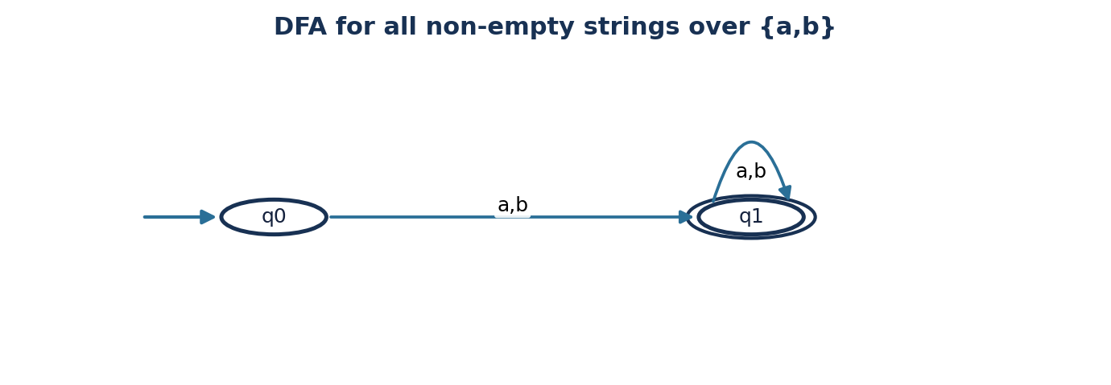
Figure 5. DFA for all non-empty strings
State | Input a | Input b | Status
→ q0 | q1 | q1 | Non-final
* q1 | q1 | q1 | Final

Reasoning and tests

- q0 is the start state and is non-final, so the empty string ε is rejected.
- Reading either a or b moves the automaton to q1, meaning at least one valid symbol has been read.
- q1 loops on both a and b, so every further symbol keeps the string accepted.

Input | Run | Result
ε | q0 | Reject
a | q0 → q1 | Accept
b | q0 → q1 | Accept
ab | q0 → q1 → q1 | Accept
bba | q0 → q1 → q1 → q1 | Accept

Conclusion : The two-state DFA is complete and minimal for Σ⁺. No dead state is required because every symbol in the alphabet is valid from every reachable state.

